Schuster, Cameron J (notes mainly from Linked In website)
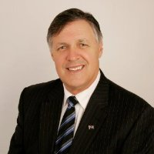
BSc Forestry ANU. Had 22 years of experience in the Western Australian public sector in a variety of land and forest management, nature conservation, disability services, human resource, finance and senior waste management/environment protection roles. District Manager in Forests Department Collie and Busselton, transferred to Manjimup in 1985. In 1989 transferred from CALM to the Authority for Intellectually Handicapped in Perth.

Manager Environment and Manufacturing Support CSBP (a subsidiary of Wesfarmers Limited) 1998 – 2008. Was responsible for CSBP's environmental management in close liaison and consultation with operations and executive management as well as public safety (for about 7 years), emergency response (for about 7 years), the product quality laboratory; project approvals (large and small); contaminated site management and clean up; waste management and legacy wastes; electricity contracts (for about 2 years until left CSBP); relevant industry body representation; and importantly regulatory management and maintenance and improvement of the various licences to operate held by CSBP.

Sustainability Manager Wesfarmers April 2008 – December 2012. Responsible for sustainability reporting, carbon and energy reporting, carbon, sustainability and other policy, contaminated land, other public reporting Australia and internationally, relevant investor and analyst briefing, environmental, packaging, waste and related regulatory management, energy efficiency and regulator relationships.

Director and Principal, Cameron Schuster and Associates Pty Ltd February 2013 – . Mount Pleasant (Perth).

